**Data Engineering Assignment – 9**

**DIFFERENT METHODS TO GET UNIQUE VALUES FROM A LIST:**

* Using set () method

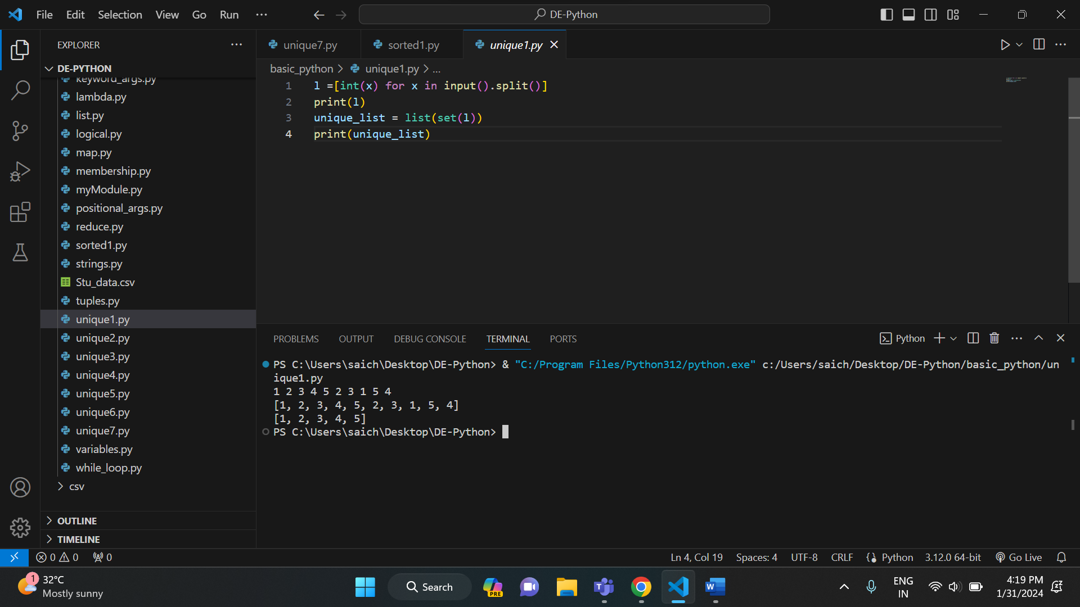

* Using reduce () method:

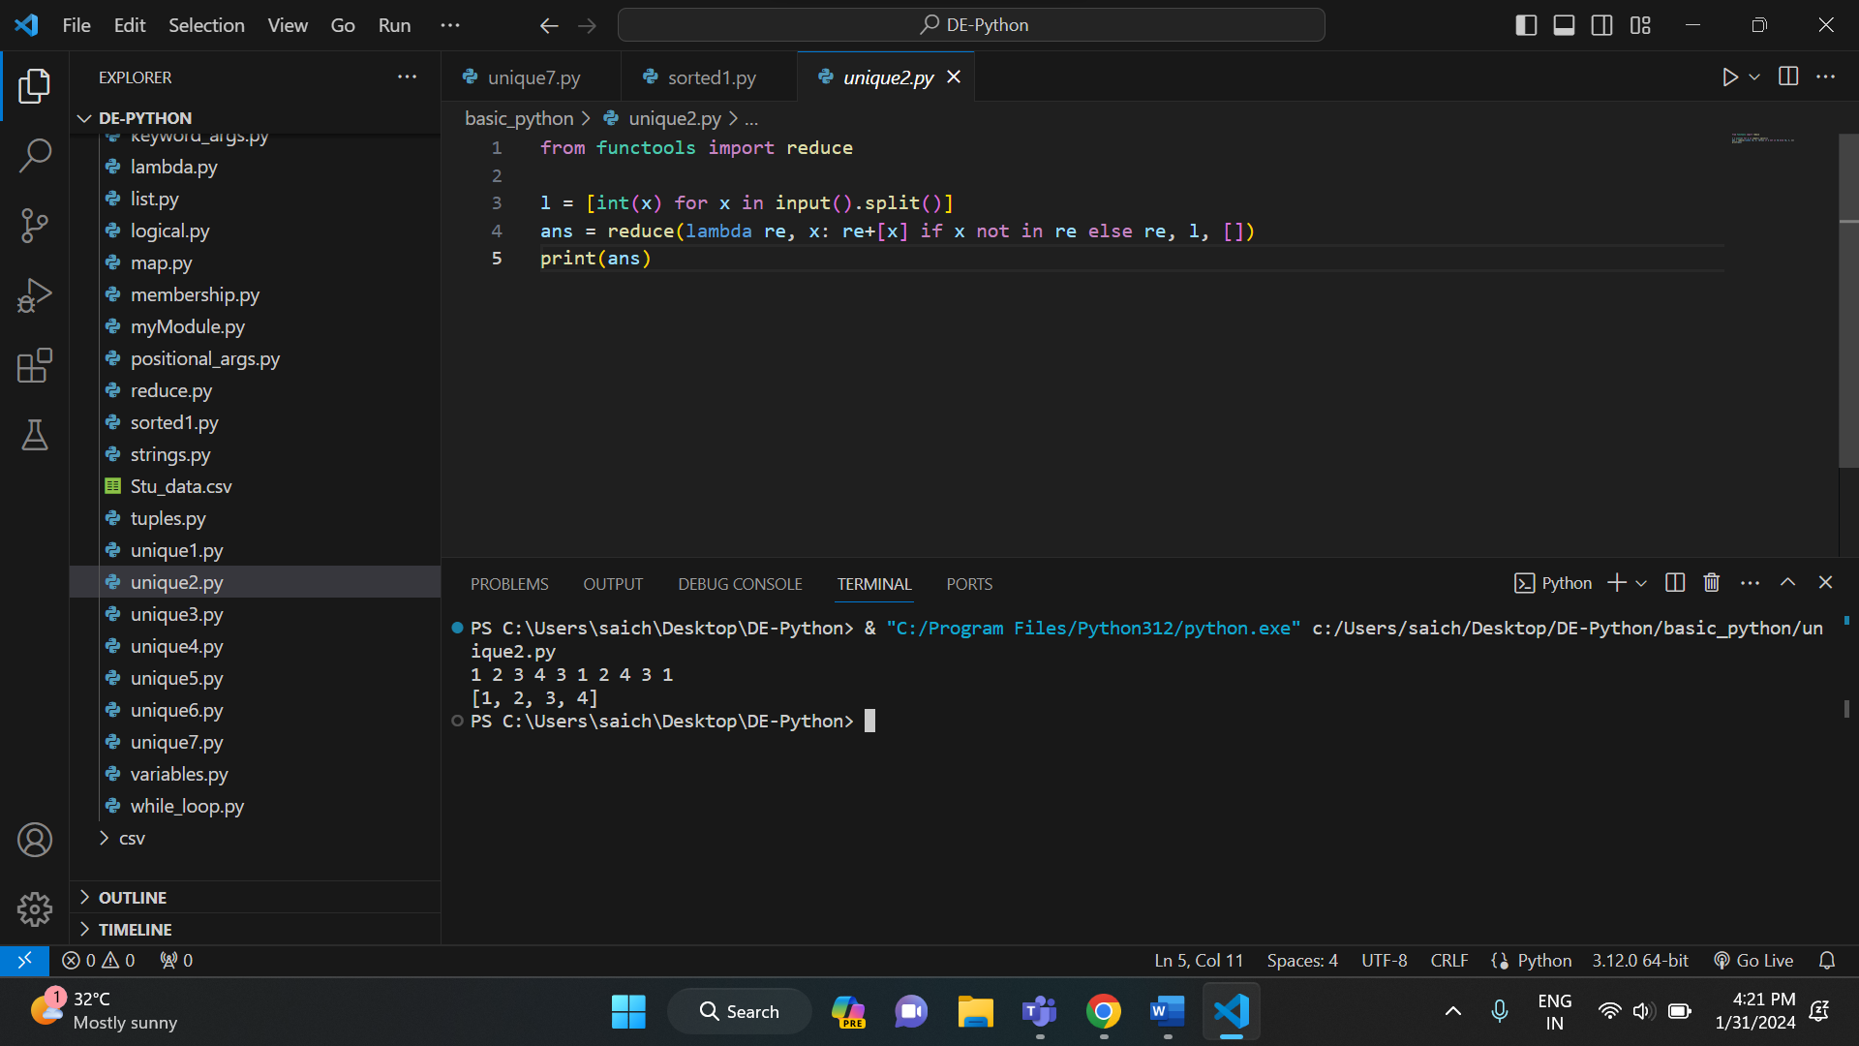

* Using operator. countOf () method:

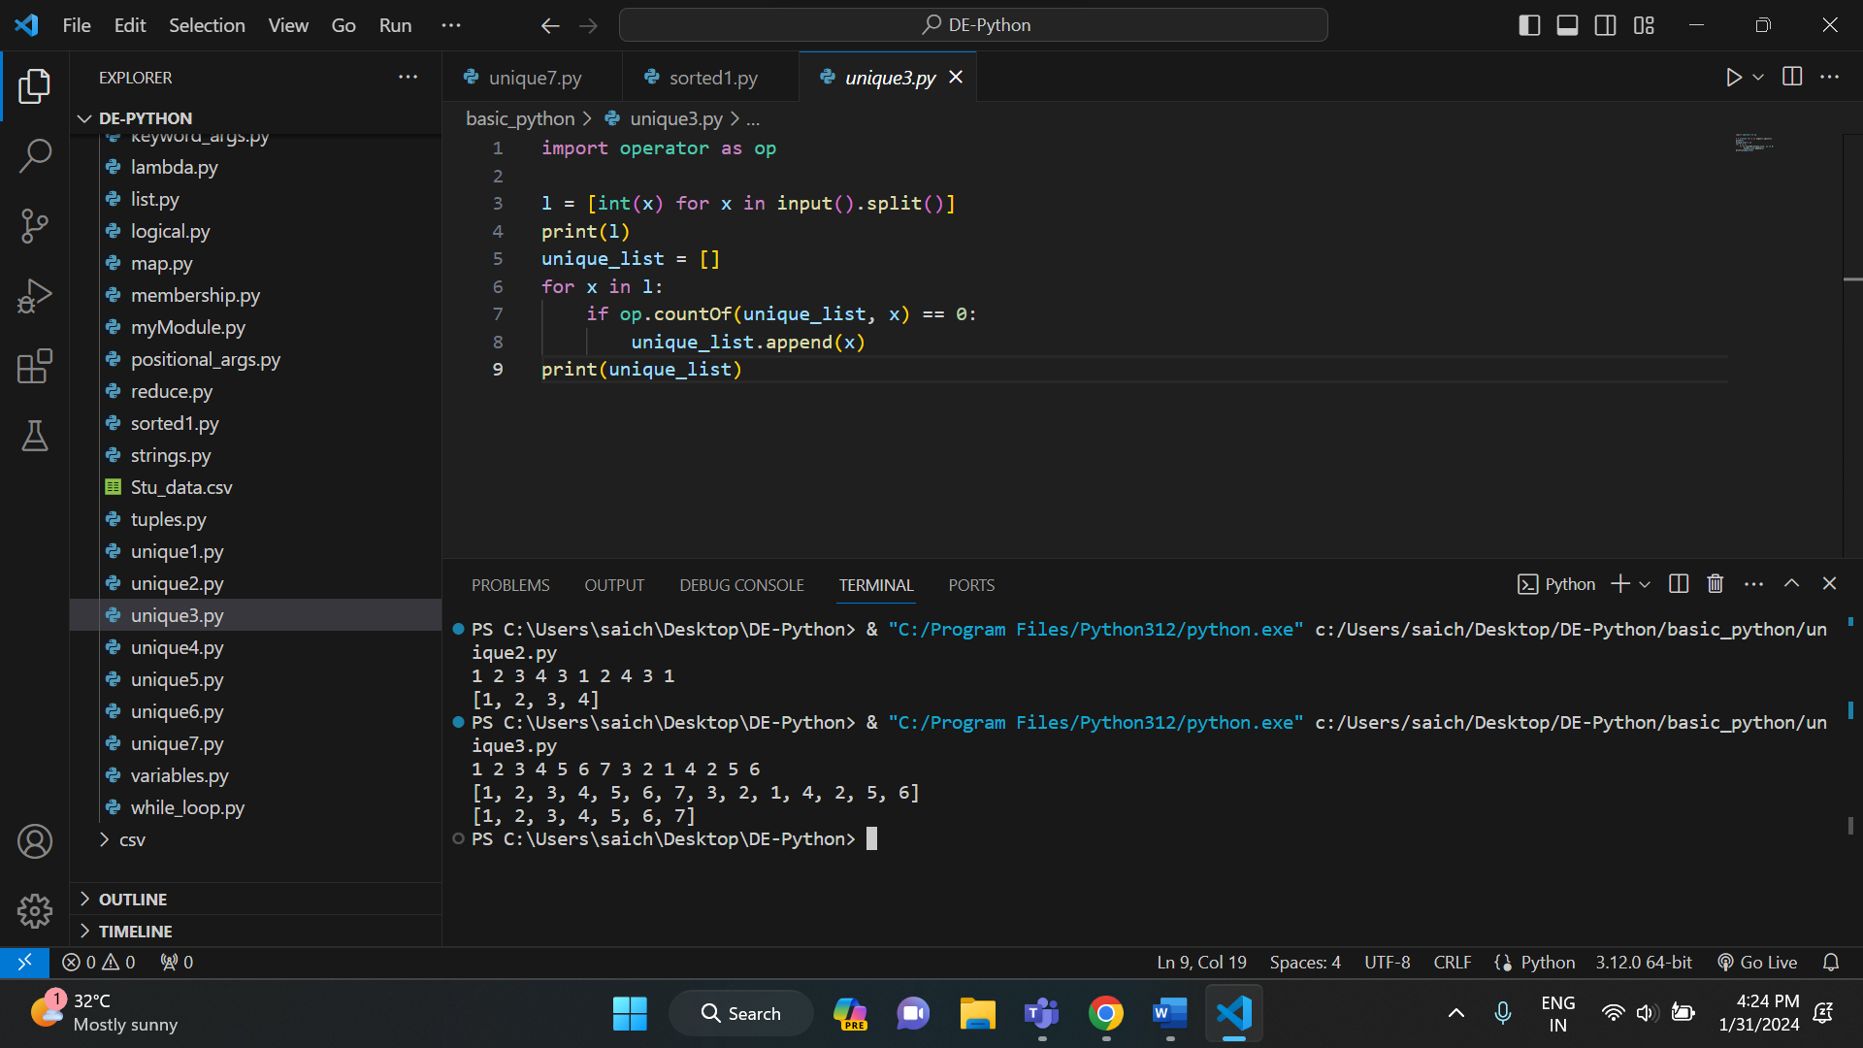

* Using pandas module:

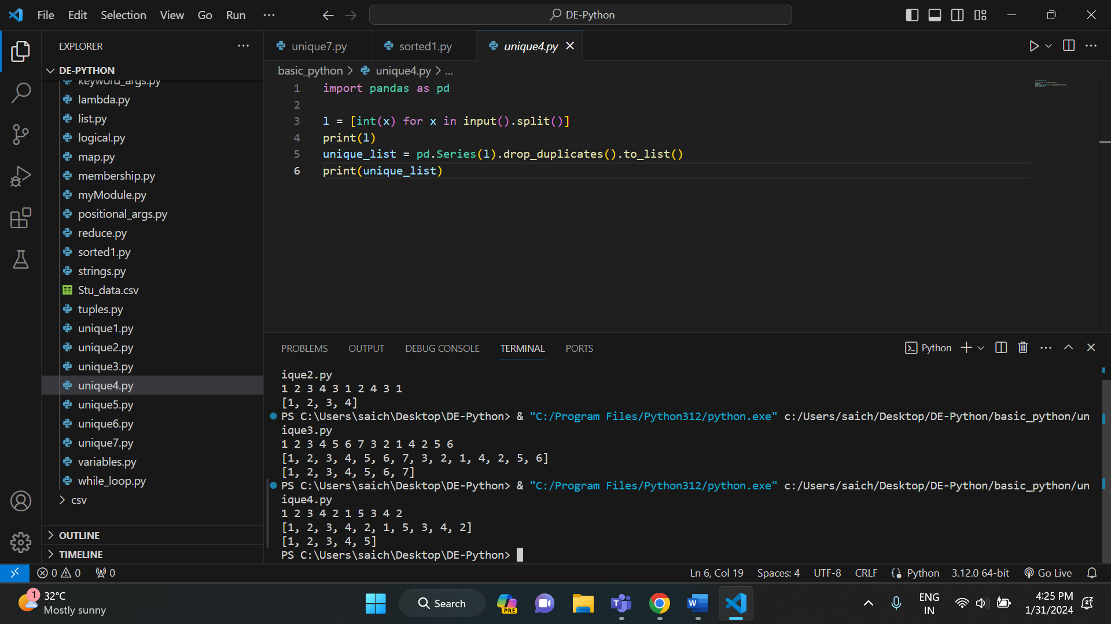

* Using numpy. Unique method:

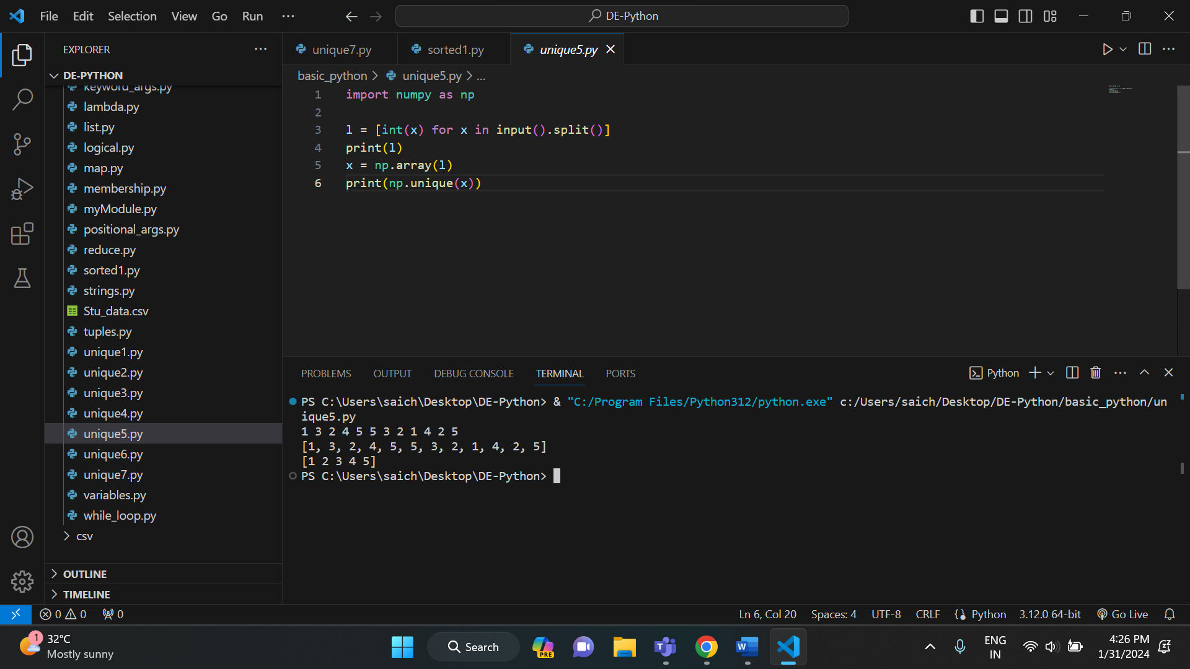

* Using collections. Counter () method:

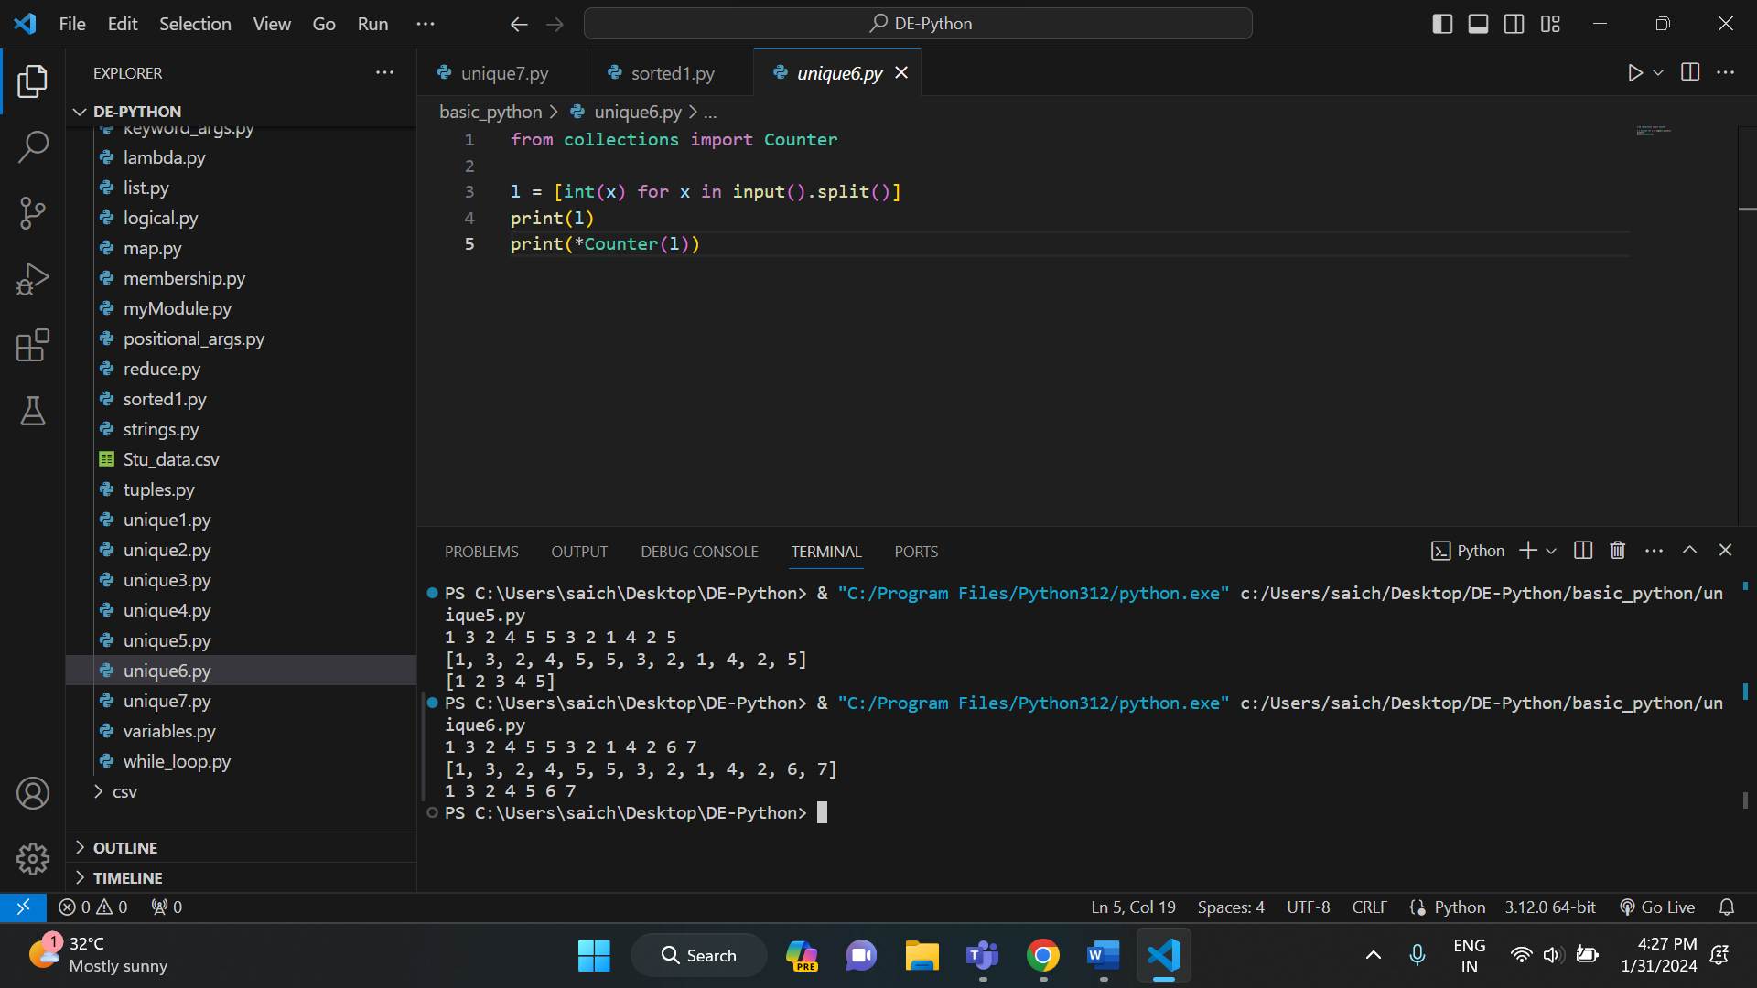

* Using dict. Fromkeys ():

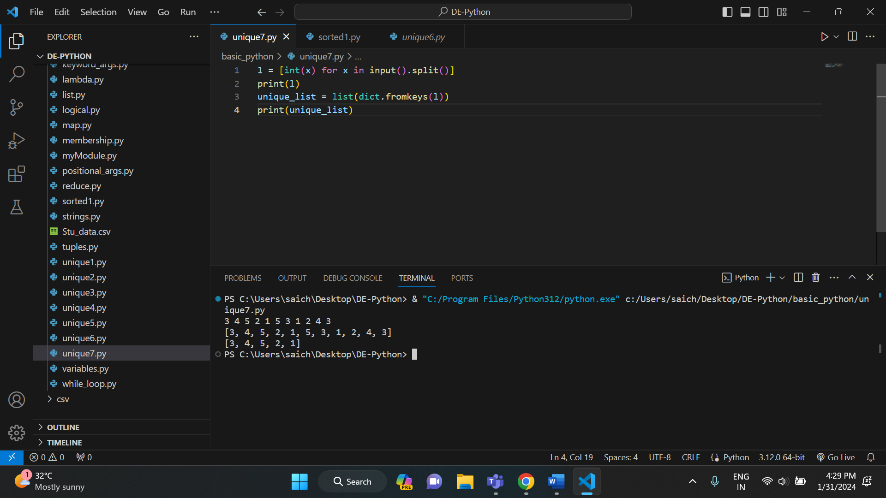

**SORT PYTHON LISTS:**

* Using sorted ():

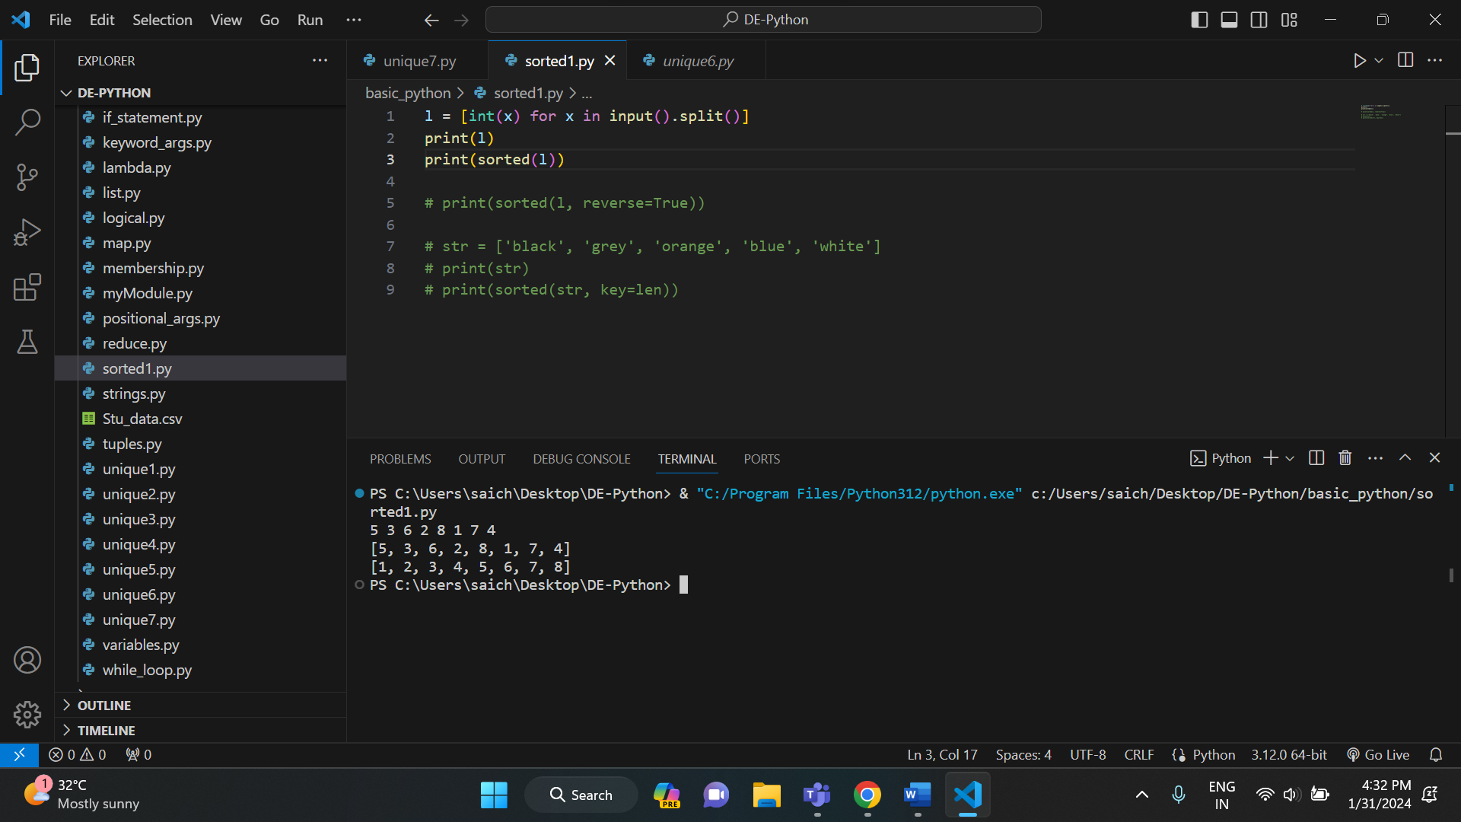

* Using sorted () with reverse argument:

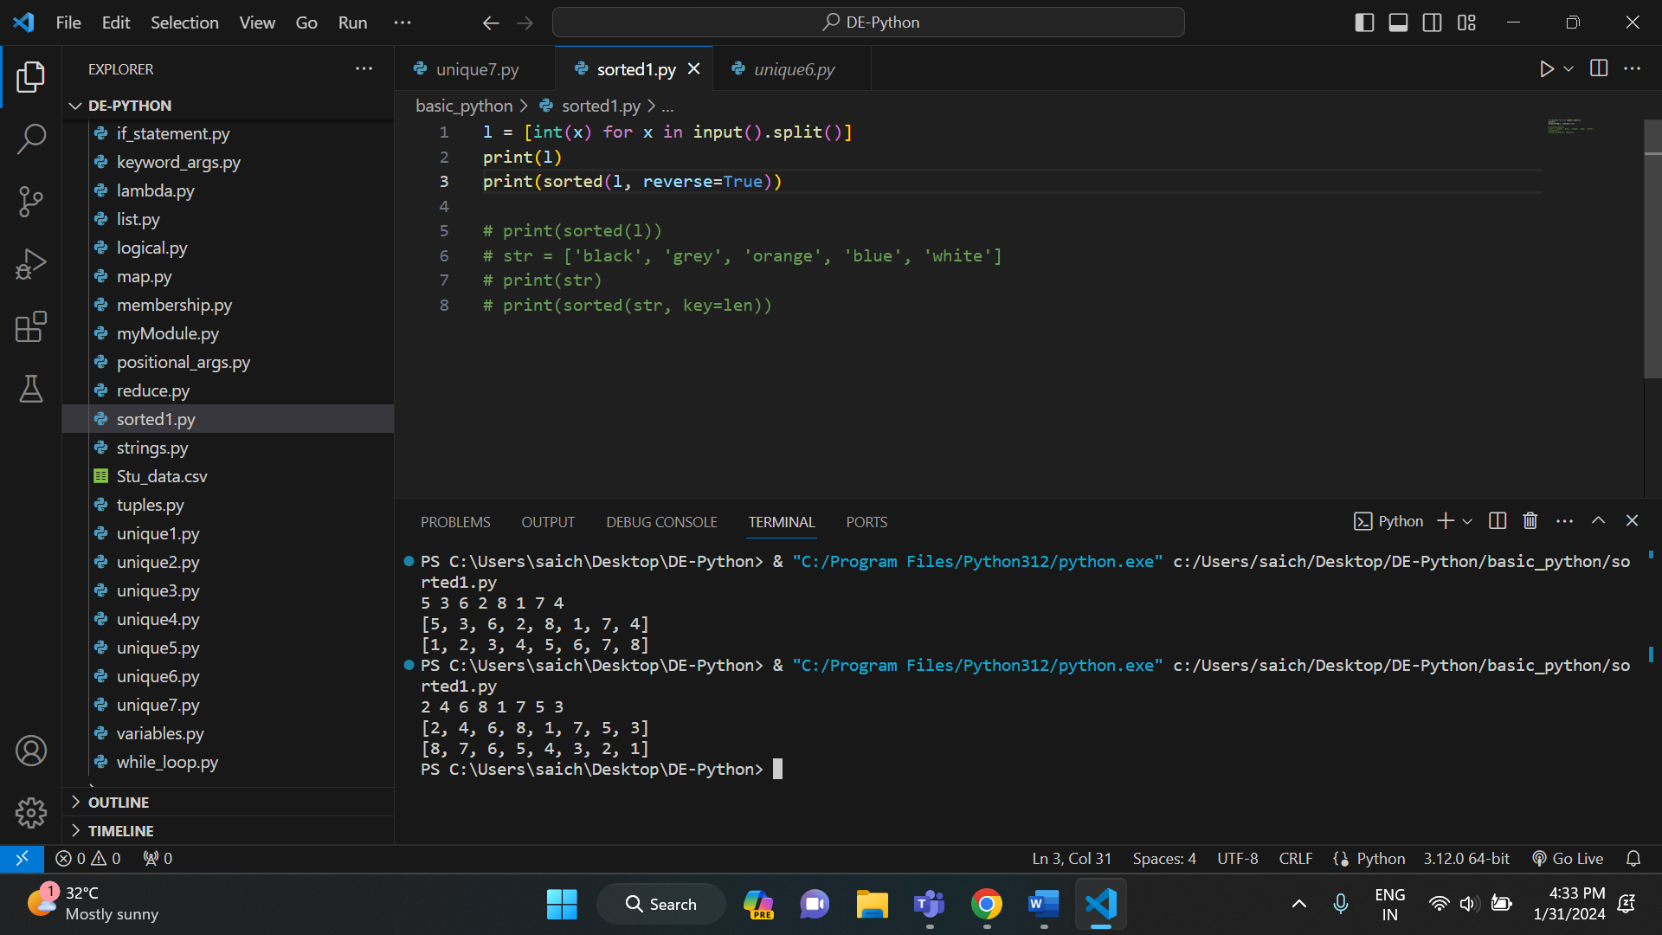

This additional reverse argument sorts the list in descending order.

* Using sorted () with key argument:

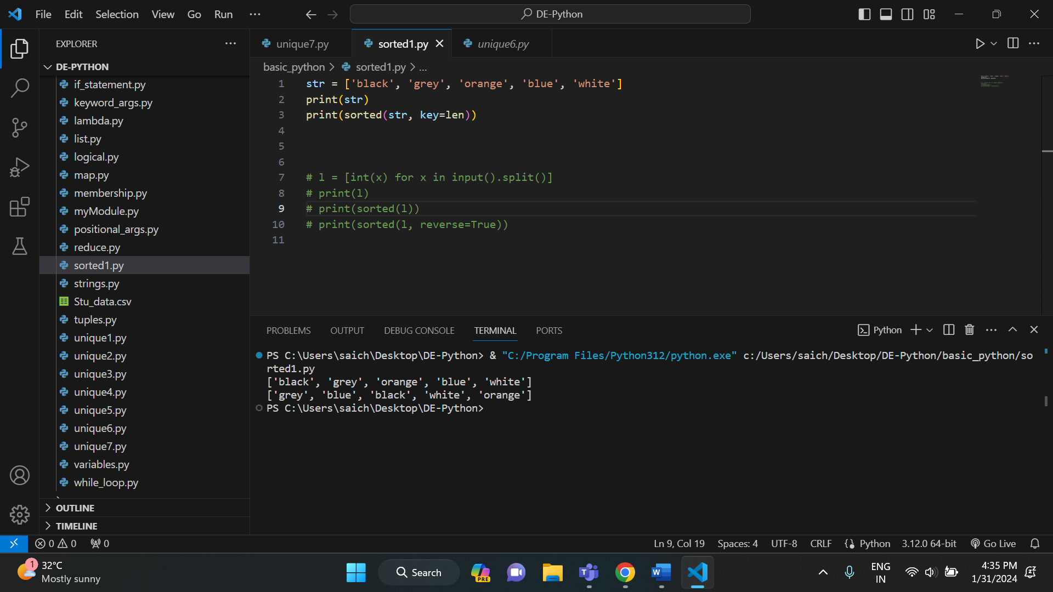

Here key = len sorts the list based on length of the strings in the list.

**JSON:**

JSON stands for JavaScript Object Notation. It is a format for structuring data. This format is used by different web applications to communicate with each other. It supports data structures like arrays and objects and the JSON documents that are rapidly executed on the server. It is also a Language-Independent format that is derived from JavaScript. The official media type for the JSON is application/json and to save those files .json extension.

**CONVERT JSON STRING TO PYTHON DICTIONARY:**

Json. Loads () is used to convert JSON string to a dictionary.

Example: 1

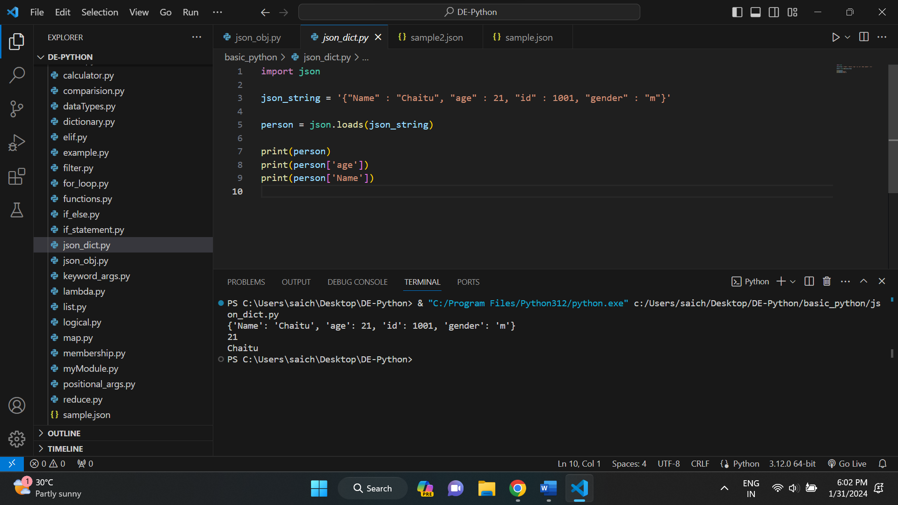

Example: 2

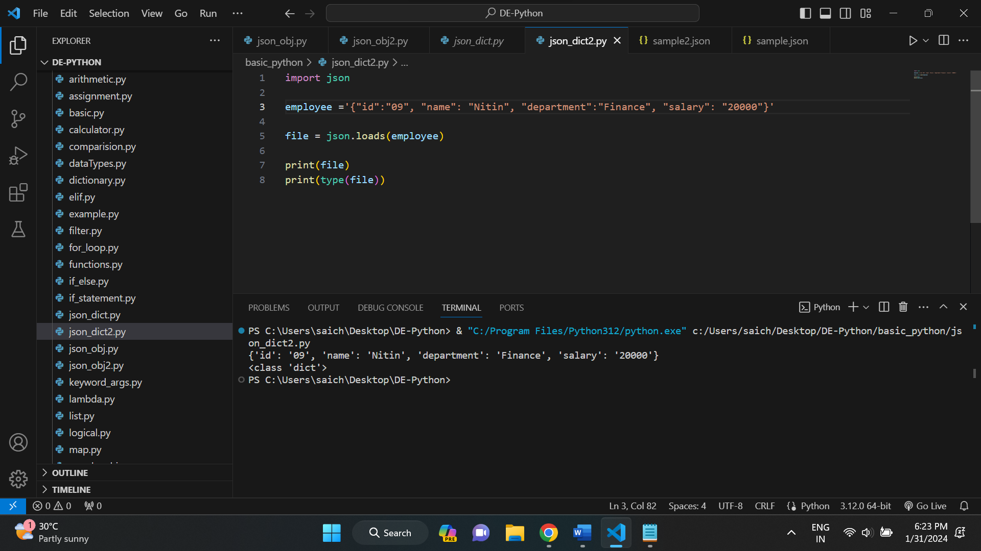

And if we want to convert a json data inside a file into python dictionary, we use json. Load () method.

Example 1:

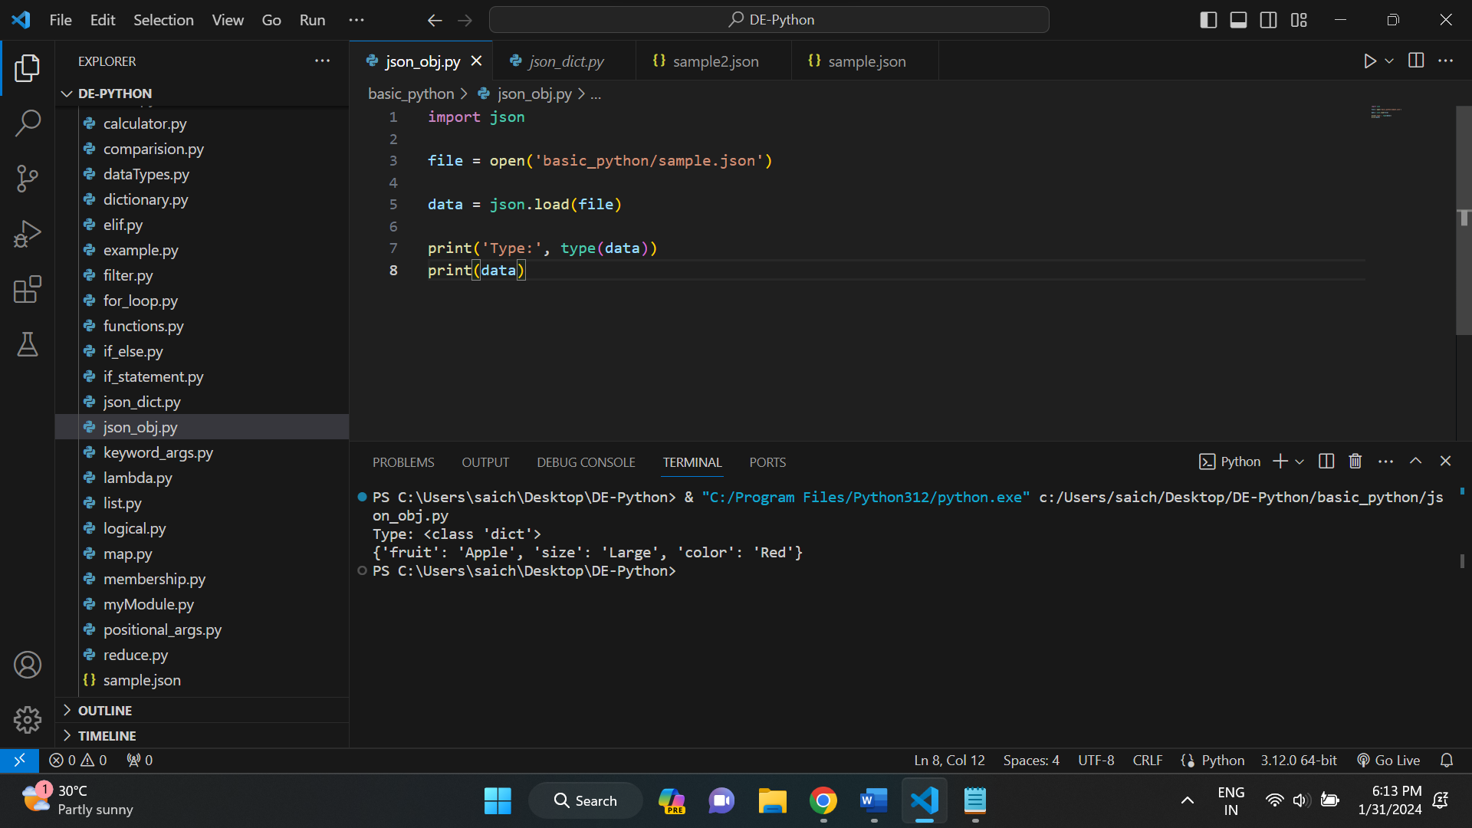

Here the json data is taken from sample. json file. And below is the sample. Json file.

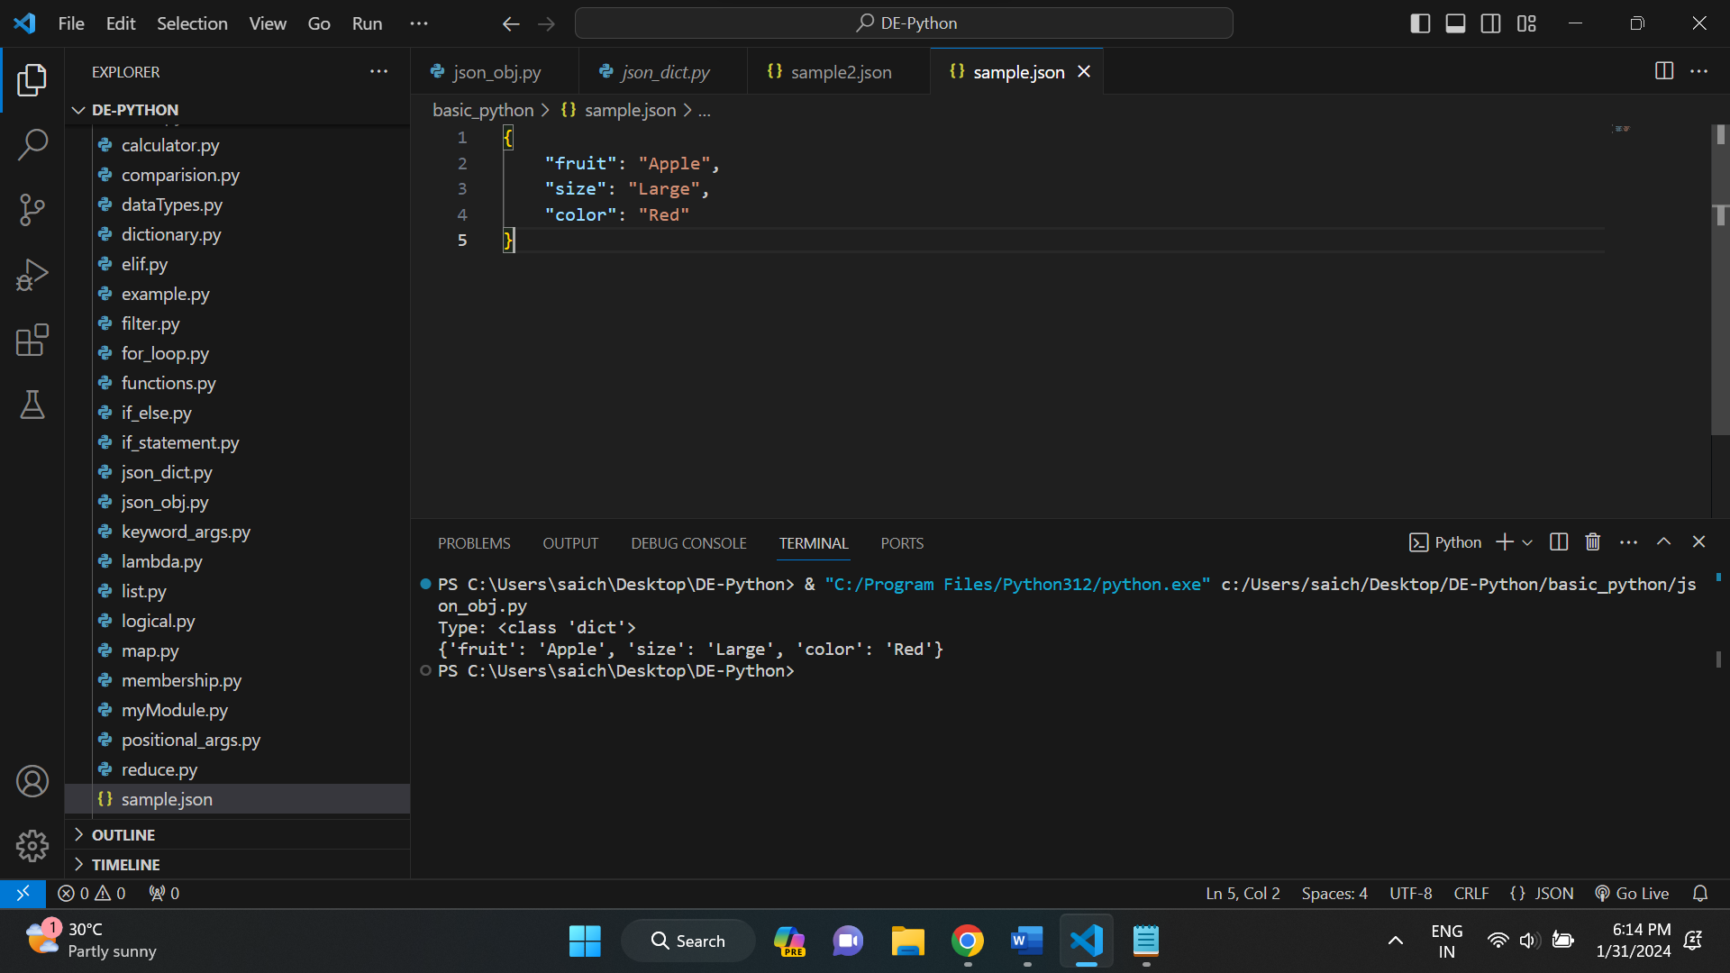

Example: 2

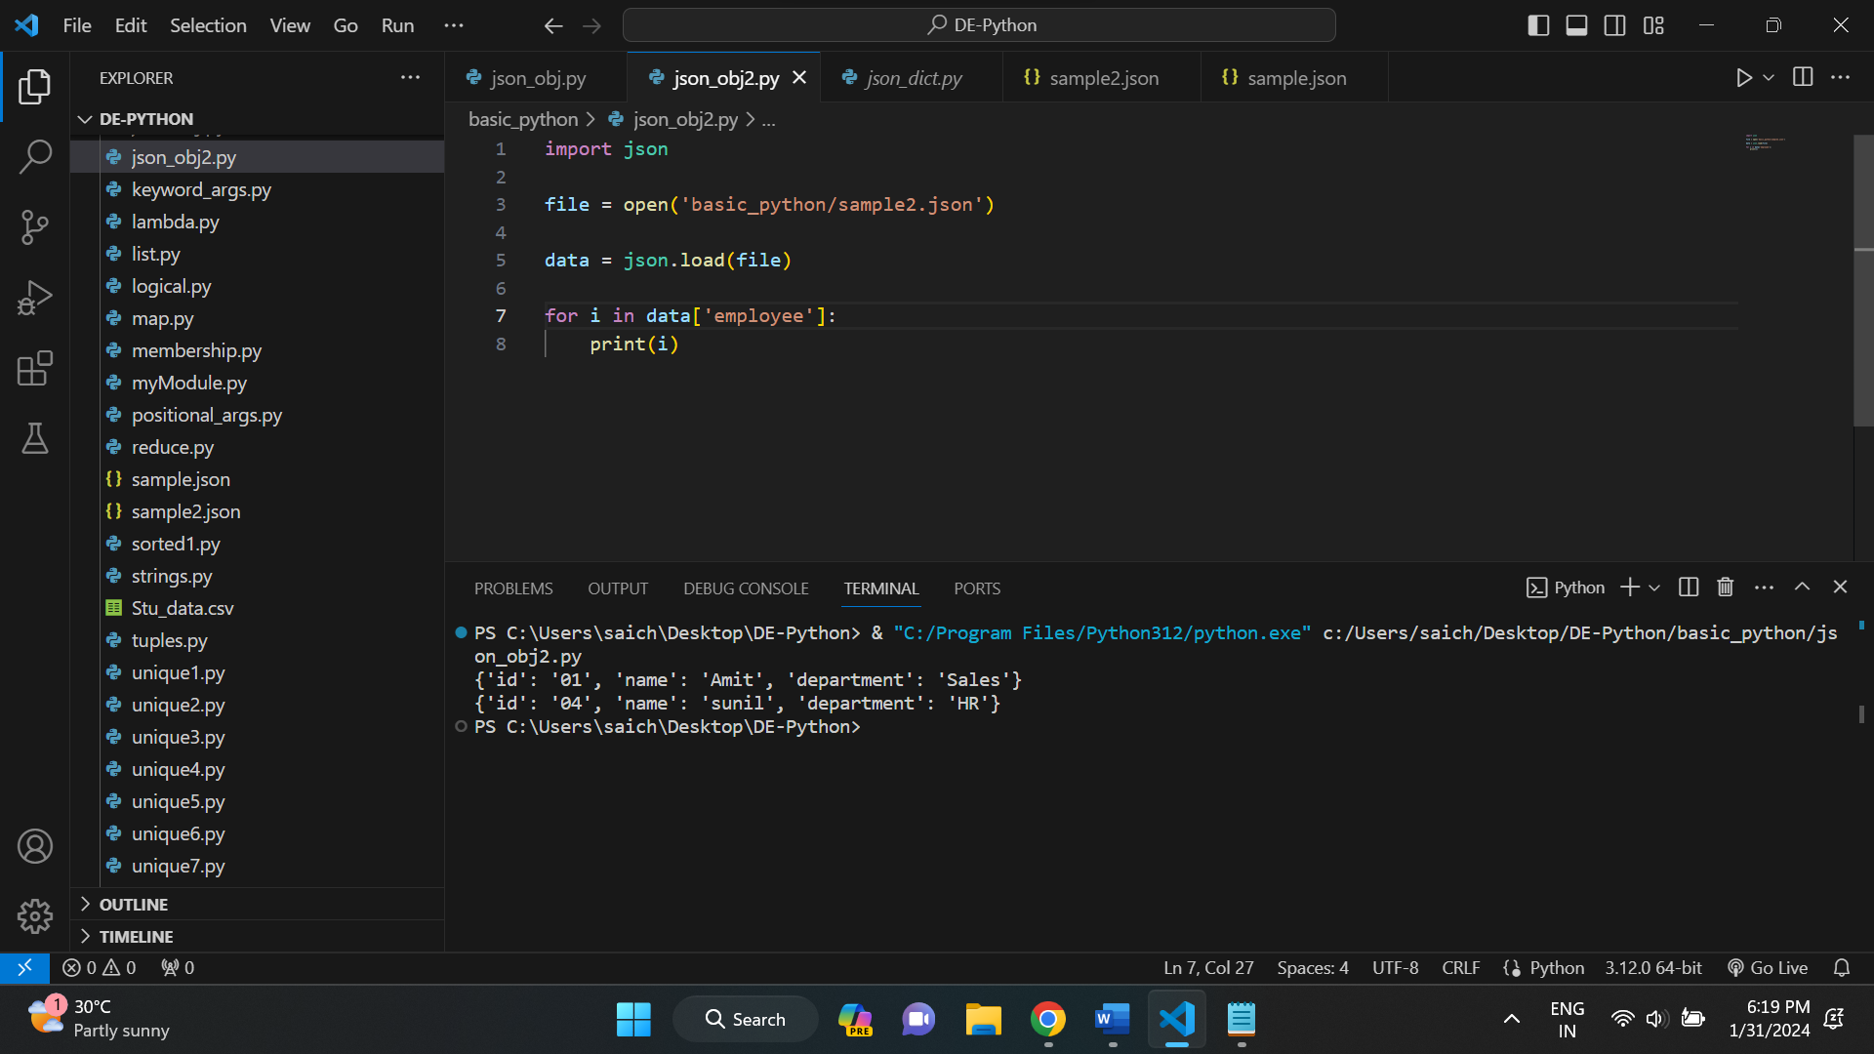

Here the json data is taken from sample2. json file. And below is the sample. Json file.

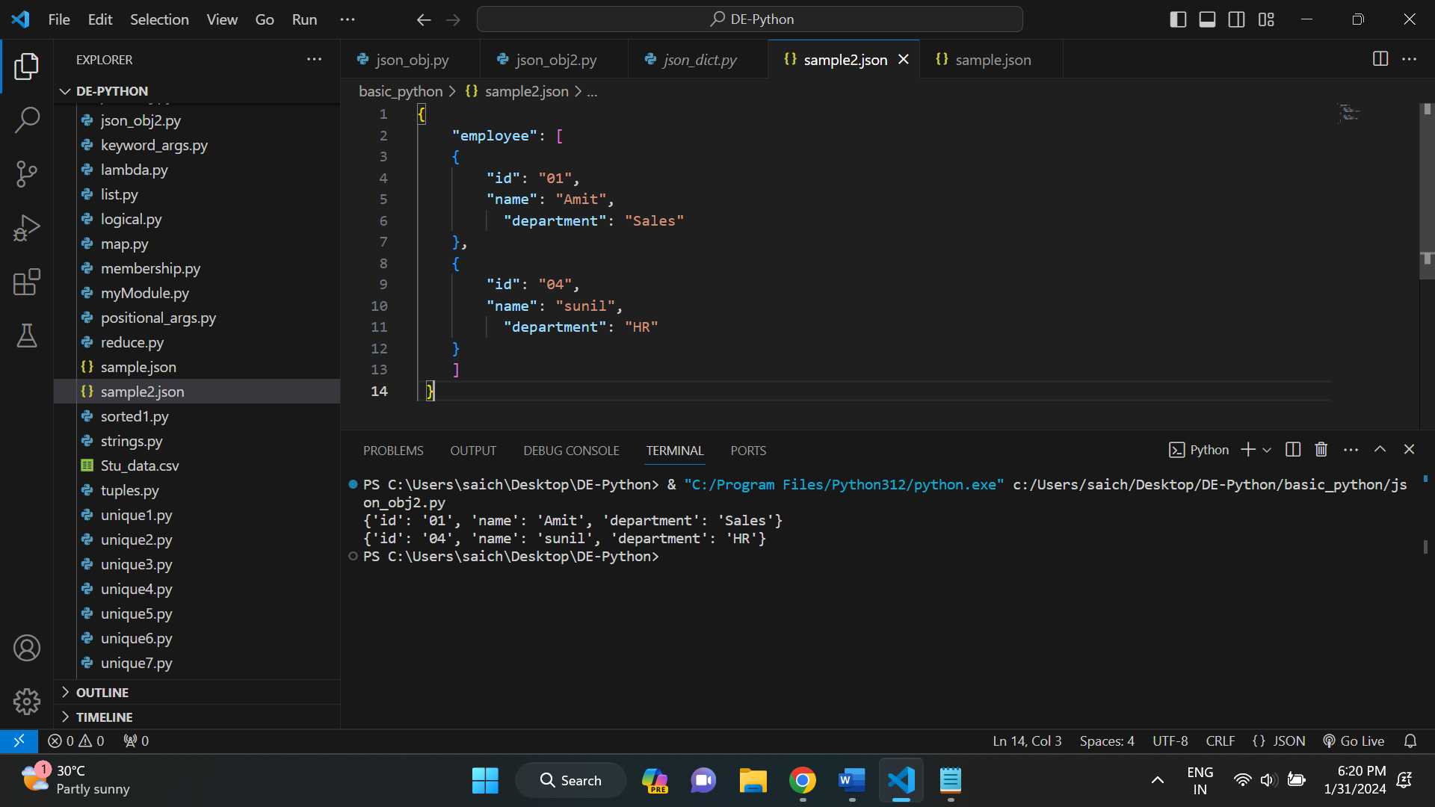

**CONVERT PYTHON DICTIONARY TO JSON:**

We can convert a Python dictionary to a JSON object using json. Dumps () method of JSON module in Python.

Example: 1

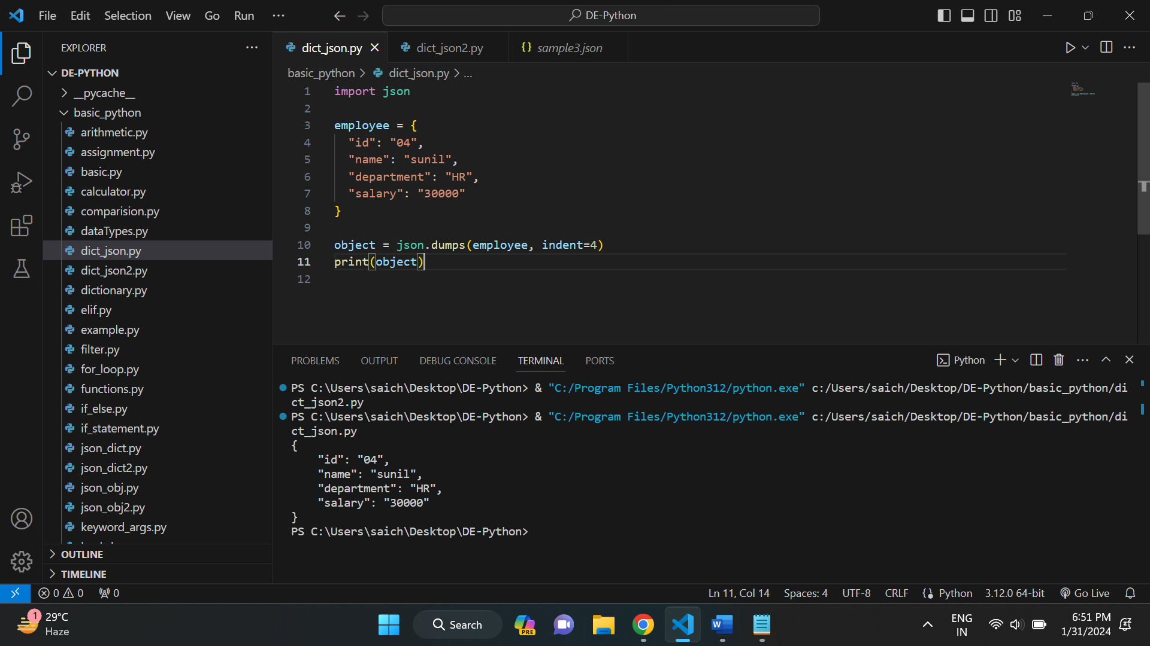

**WRITING JSON TO A FILE IN PYTHON:**

We can write JSON to file using json. Dump () function of JSON module and file handling in Python.

Example:

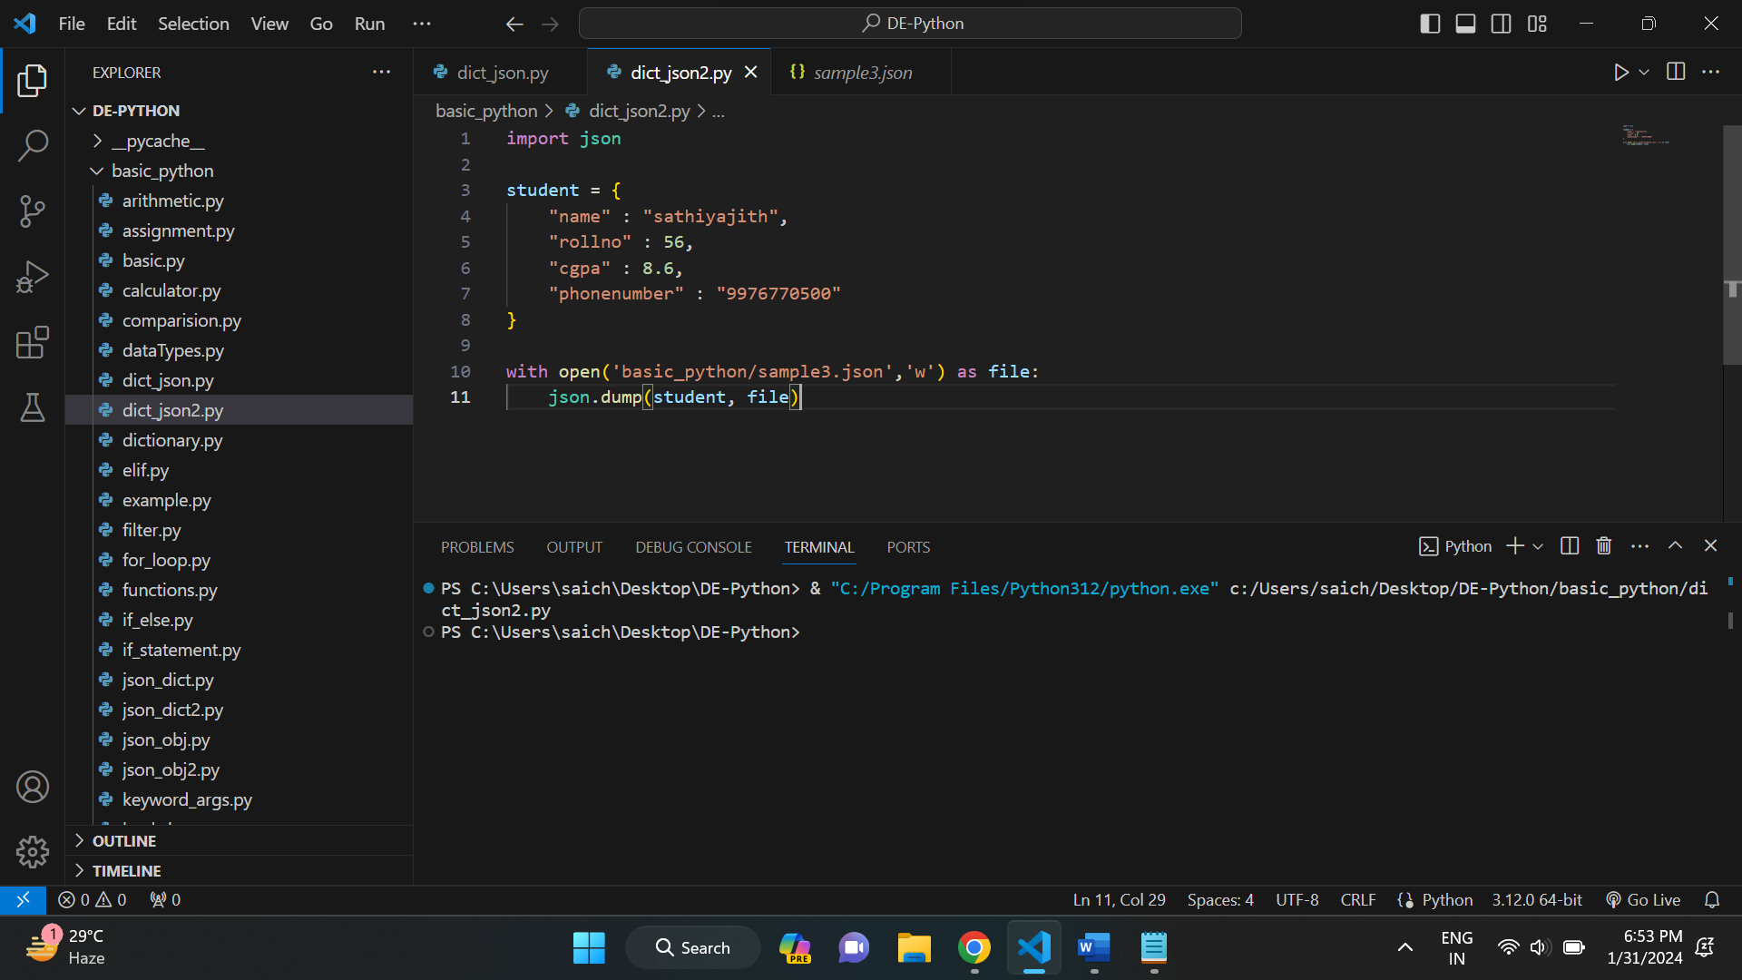

And below is the created file name as sample3.json.

